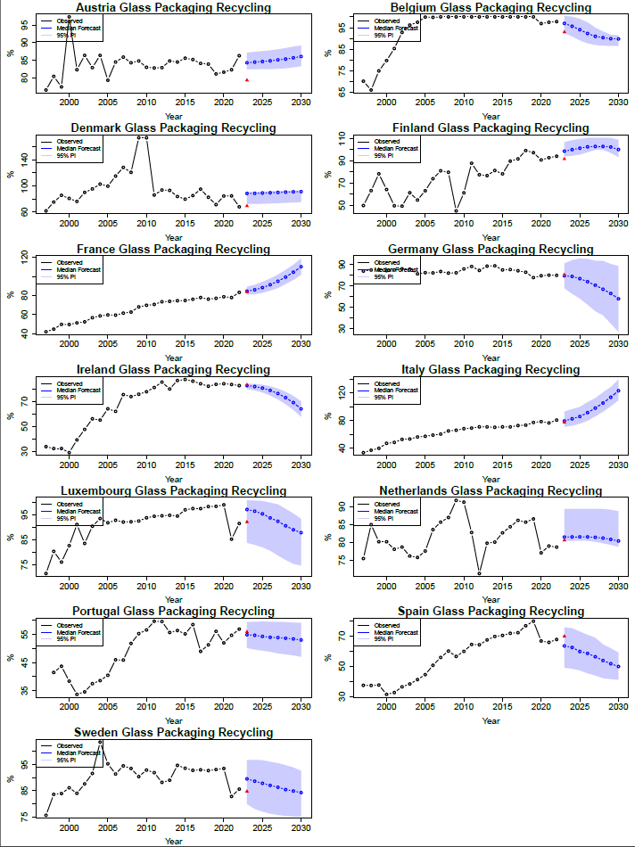
Glass Packaging

Black line – series
Red triangle – 2023 value
Blue line – forecast with PI
Performance across glass is generally strong, with the 2023 observed value falling within the 95% PI for most countries.
The largest error observed for 2023 glass packaging was in Denmark, where we predicted 88.3% and the observed value was 68.9% (out by 19.4%). The training data of Denmark is noisy, exhibiting huge jumps and drops. In 2008, the recycling rate was 120.9%, which rose to 174.2% in 2009 and 2010 before falling to 85.9% in 2011. It again rises from 71.1% in 2019 to 84.3% in 2020 before falling from 84.5% in 2021 to 67.7% in 2022. It is unsurprising that the forecast is poor, given the series’ characteristics. We would imagine most models would struggle forecast reliably from data of this nature.
Italy and France are forecasted to have recycling rates that exceed 100%, but this is plausible given the observed data of Sweden and Denmark.
Germany, Luxembourg and Sweden all exhibit relatively wide prediction intervals (PIs), but all seem to have little trend in their data, but the series appearing relatively flat when plotted. This could mean there’s less signal in the data for the models to exploit Spain also has a wide PI, but experiences a drop just before the forecast horizon (from 79.8% in 2019 to 66.7% in 2020) which may have influenced this.

Plastic Packaging
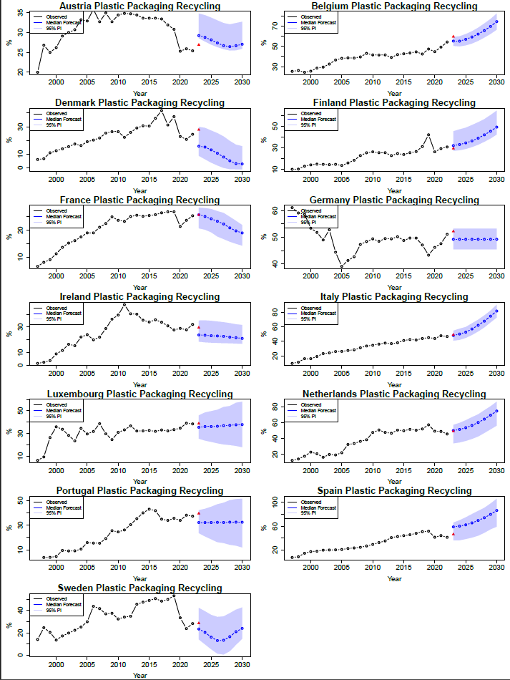
These are pretty good. Again, majority of PIs cover the observed value.
Austria is a notable case where the point forecast appears to jump relative to the recent observed level, yet the 2023 observed value also jumps, resulting in a small error of 2.3 percentage points. This suggests the model captured an underlying covariate signal even if not immediately obvious from the series alone.
Again, Denmark has a large forecast error for the 2023 value (predicted 15.8%, observed value 27.8%). The model seems to have forecast that the downward trend observed from 2017 onwards would continue, which the series seems to ticked up slightly. The series also appears to be slightly noisier towards the end, maybe making prediction more difficult.
Spain also saw a large forecast error (predicted 58.7%, observed 46.2%). The model predicted a large jump from the 41.2% value observed in 2022, however, the series didn’t jump by quite the amount as predicted.
Denmark, Luxembourg, Portugal and Sweden have wide PIs. Luxembourg has no observable trend and Portugal is relatively flat for a number of years leading up to the forecast horizon, possibly causing the wide PIs. Denmark and Sweden experience drops / noise prior to the forecast horizon, possibly hindering predictions.

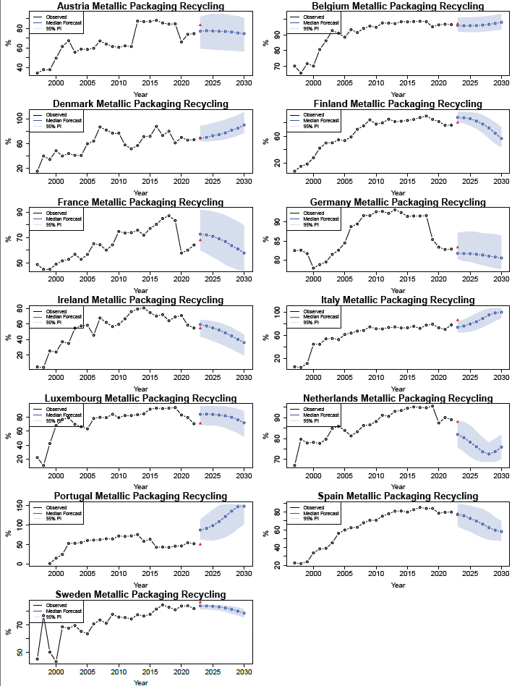
Metallic Packaging
Coverage isn’t as good here as it was in previous waste streams.
Italy has a large error here for 2023 (predicted 73.9%, actual is 86.2%). We predicted a small decrease from the 2022 figure of 78%, while there was actually a large jump.
There is a large 2023 error for Luxembourg (predicted 71.1%, observed 84.2%). The model over-predicted the rise in 2023 from the 2022 value of 70.7%.
Portugal also had a large 2023 error (predicted 87.5%, observed 50.2%). The model’s PI is also considerably wide. However, the series is one of the noisiest we’re working with. There’s a large jump in this series from 24.3% in 2001 to 52.8% in 2002 with a drop from 75.7% in 2013 to 58.3% in 2014. There is another drop from 63.6% in 2015 to 42.9% in 2016. This noise will affect forecast performance and PI width.
Austria, France, Luxembourg and Portugal all have wide PIs. Austria observes a jump from 61.4% in 2012 to 87.5% in 2013 and a drop from 84.7% in 2019 to 66.1% in 2020, possibly adding noise to the series. France sees a drop in 2020 from 83.4% to 57.9%. Luxembourg sees a ~10% drop in 2021.

Paper & Cardboard Packaging
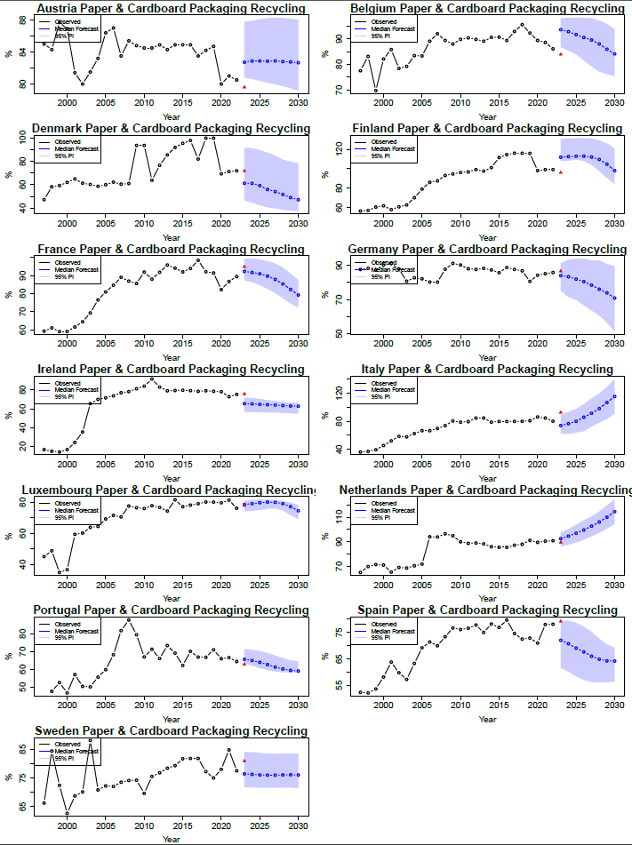
This is the worst stream of the lot. Coverage isn’t fantastic.
We have a large 2023 error for Belgium (predicted 93.6, observed 83.9). The model predicted a rise on the 2022 value of 86.1% when it actually fell slightly.
The 2023 error for Denmark occurs as we predicted a drop while it stays relatively the same. The PIs are also quite wide. Again, the Danish data is noisy here, experiencing lots of drops and rises.
Finland’s and Ireland’s large 2023 errors can be explained as the model predicts a jump when the data stays the same.
Italy’s large 2023 error is explained by a jump in the series. The 2022 value was 80%, we predicted 73.9%, the series jumped to 92.6%.

